Cubic Functions Examples:

1) Solve the equation
x^3-3x^2+3x-1=0

This equation can be factored to (x-1)^3=0

So although there are three factors, they are all the same and we only have a single solution x= 1. The corresponding curve is y=x^3-3x^2+3x-1.

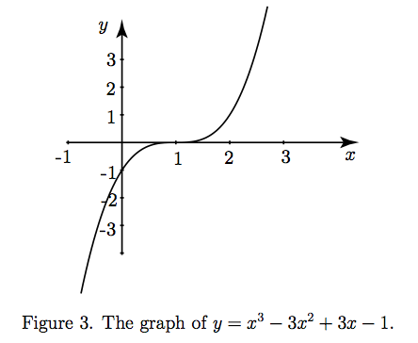

2) Example:
Plot the graph of y = x³ – 9x + 5 for –4 ≤ x ≤ 4 and use your graph to find:
a) the value of y when x = 1.6
b) the value of x when y = 12
x | –4 | –3 | –2 | –1 | 0 | 1 | 2 | 3 | 4
y | –23 | 5 | 15 | 13 | 5 | –3 | –5 | 5 | 33

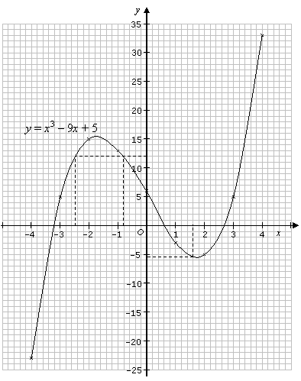

a) When x = 1.6, y –5.3
b) When y = 12, x –0.8, or x –2.5

